

**MACHINE LEARNING FILE**

**SUBMITTED BY-**

**BHAVNOOR SINGH**

**01813202717**

**CSE-1**

**EXPERIMENT-1**

**Github link for code :**

https://github.com/Bhavnoor-Singh98/ML_LabWork/blob/main/lab_program3.ipynb

# AIM:

# Study and implement the Naive Bayes learner on a breast cancer dataset

# ALGORITHM:

1. Convert the data set into a frequency table
2. Create Likelihood table by finding the probabilities.
3. Now, use Naive Bayesian equation to calculate the posterior probability for each class. The class with the highest posterior probability is the outcome of prediction

# PROGRAM CODE SNIPPET:

## LOADING DATA SET:

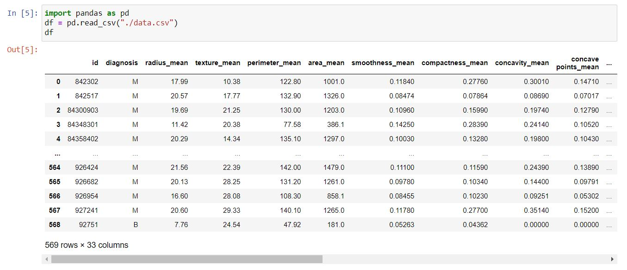

## PREPROCESSING:

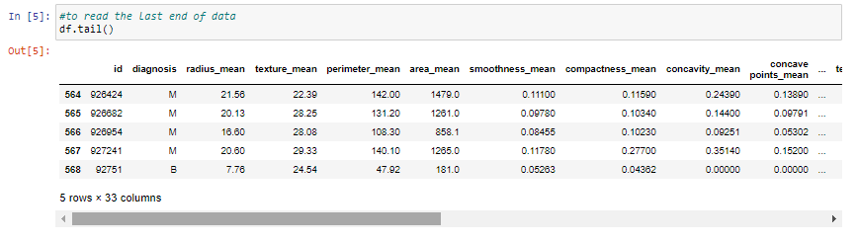

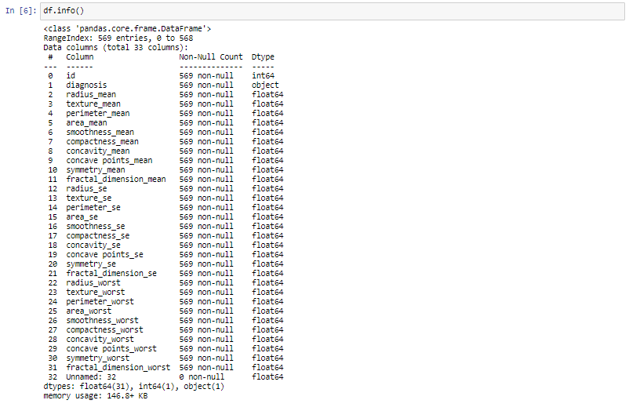

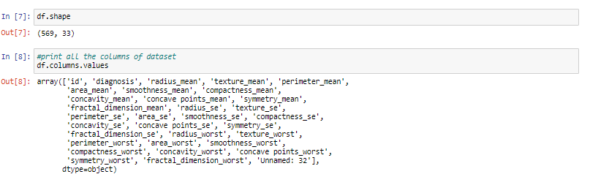

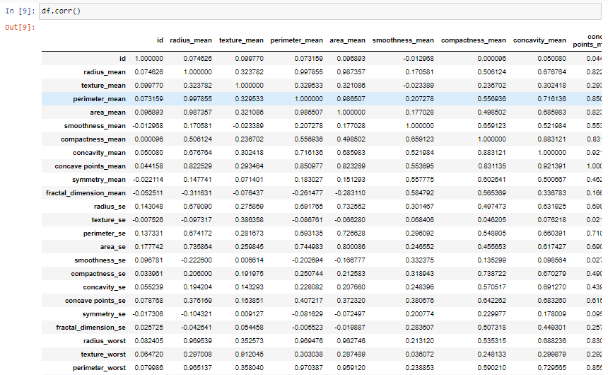

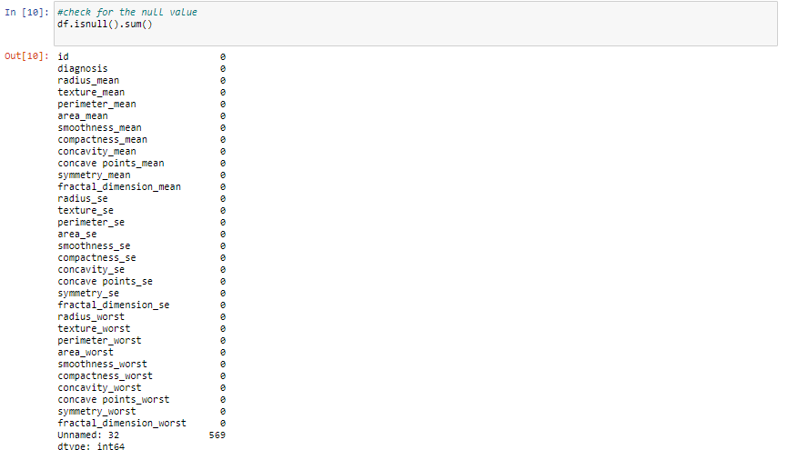

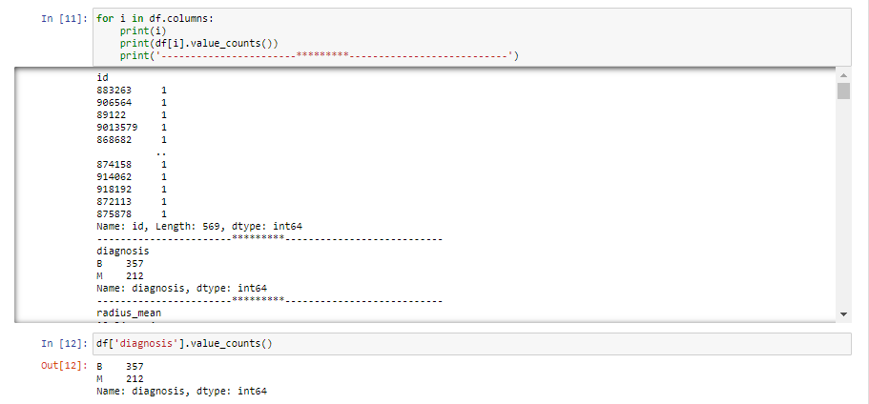

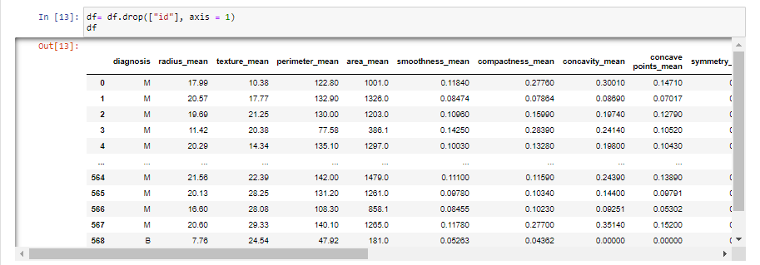

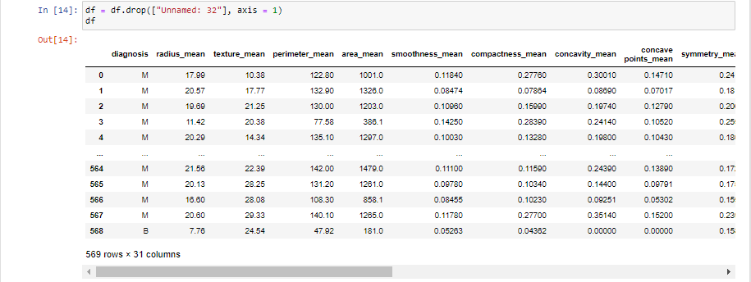

## VISUALIZATION:

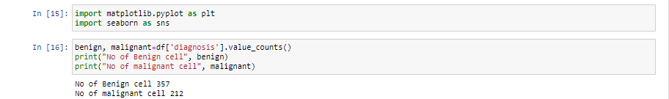

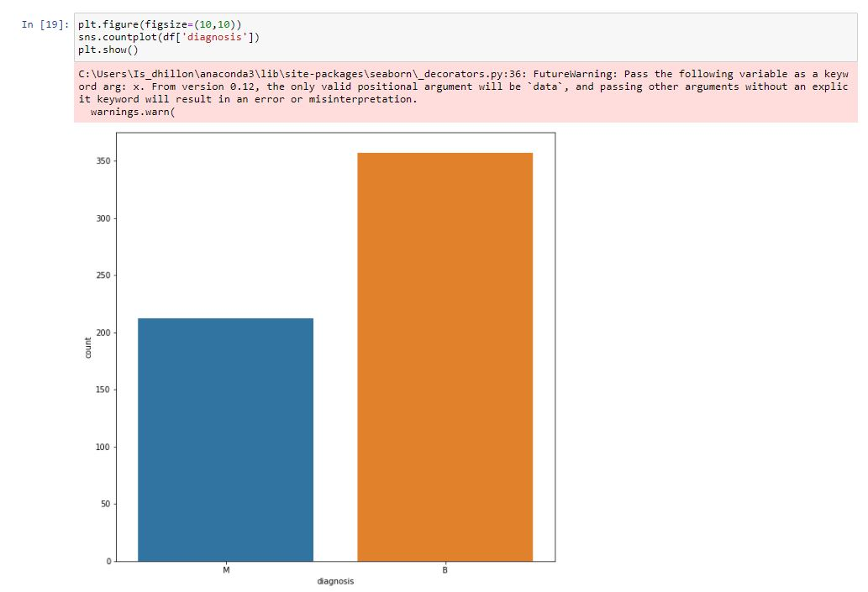

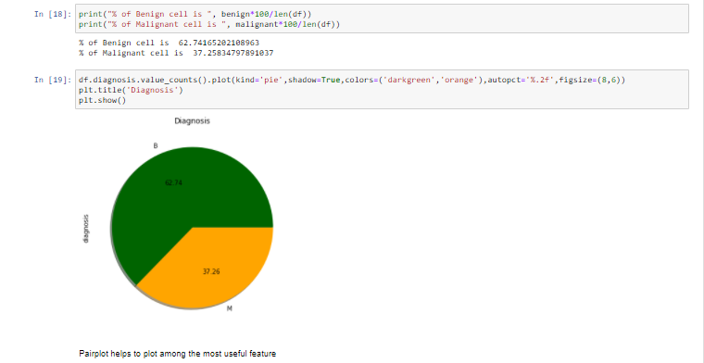

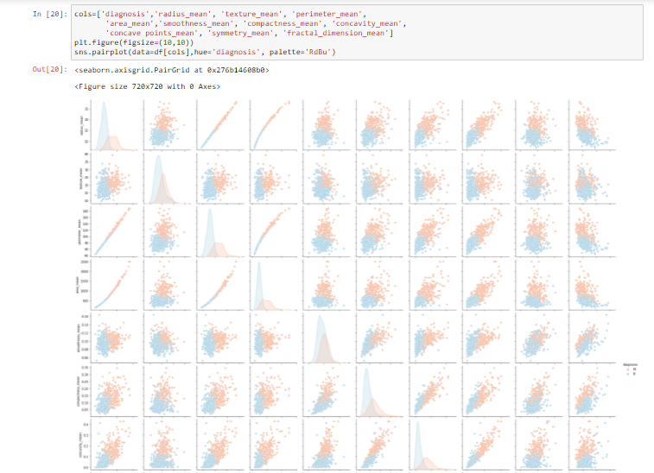

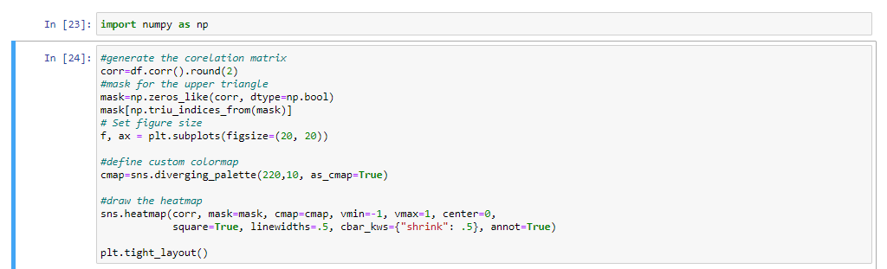

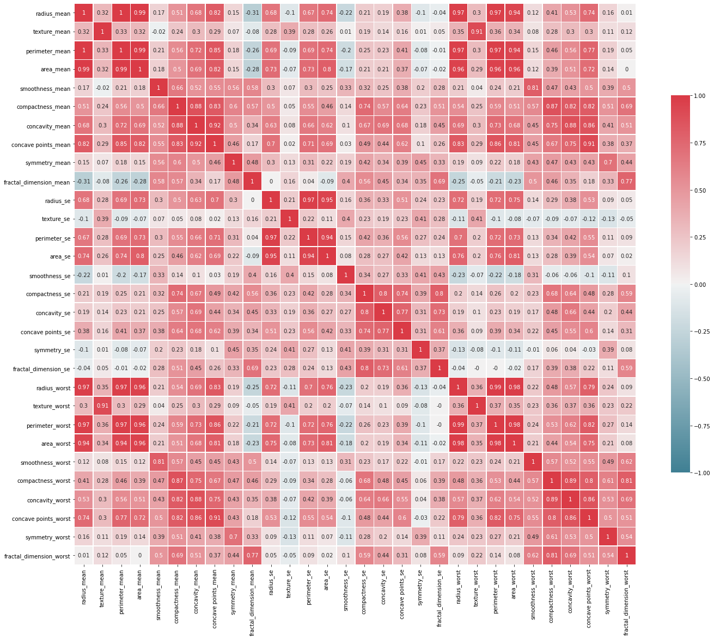

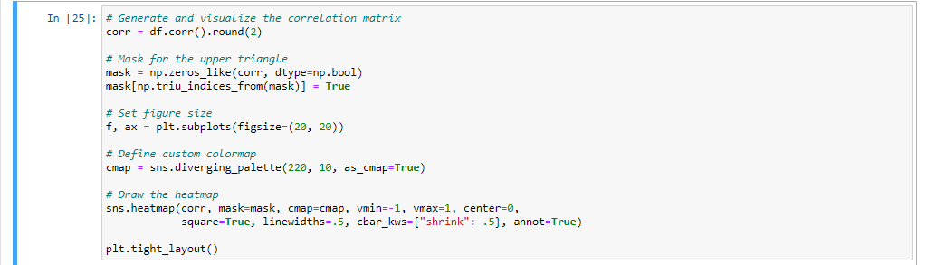

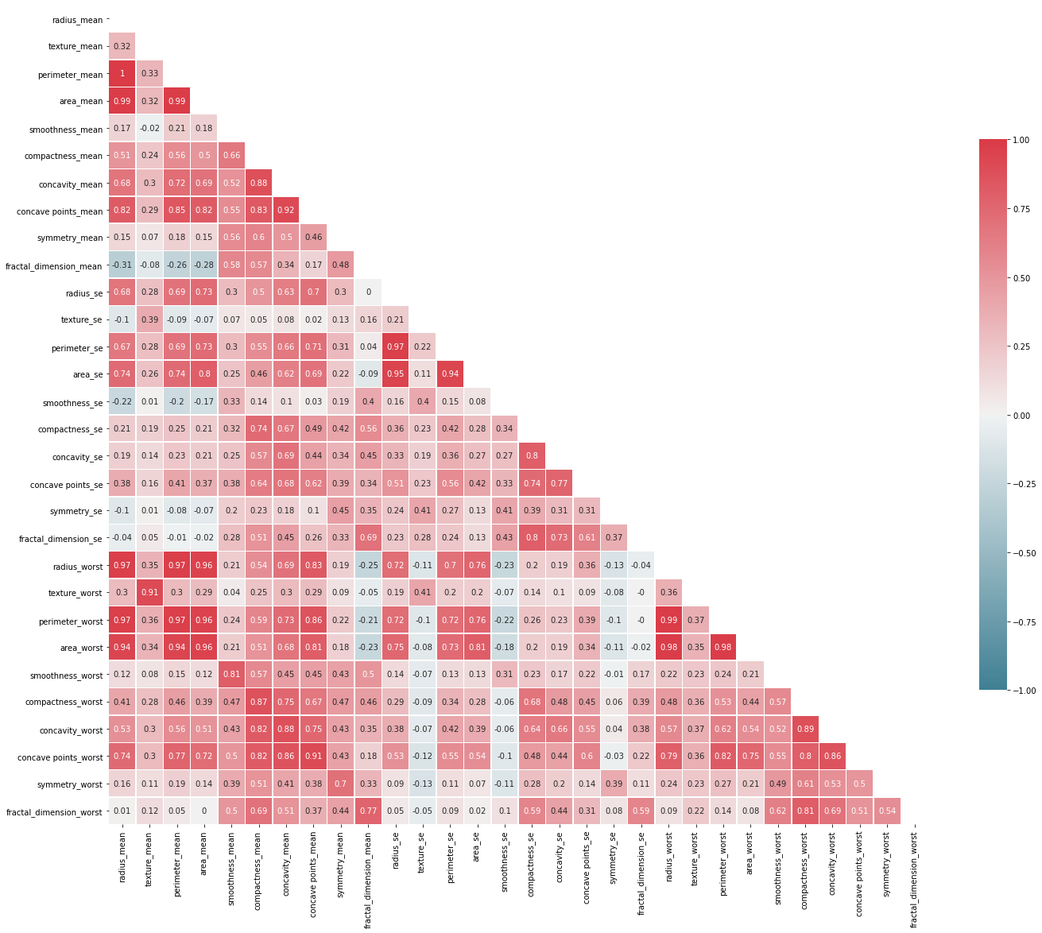

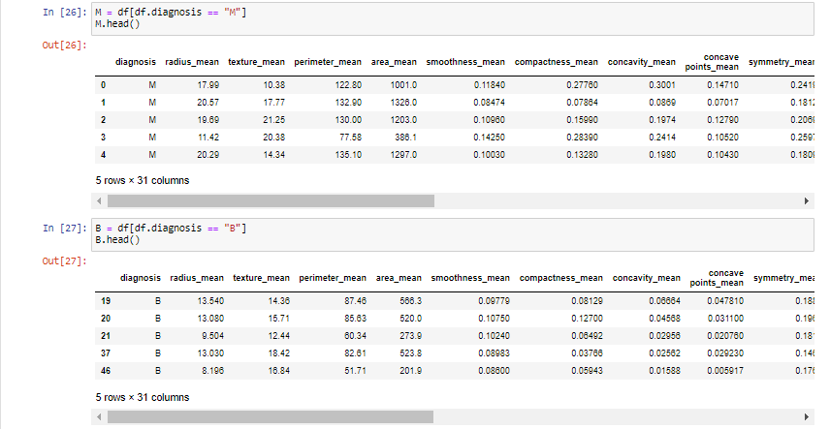

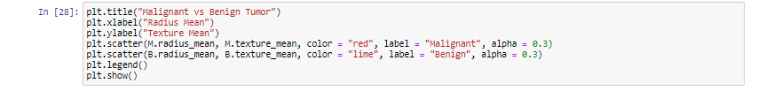

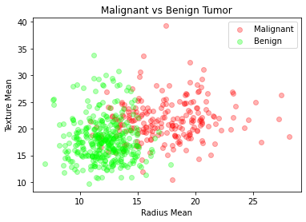

## ML ALGORITHM IMPLEMENTATION:

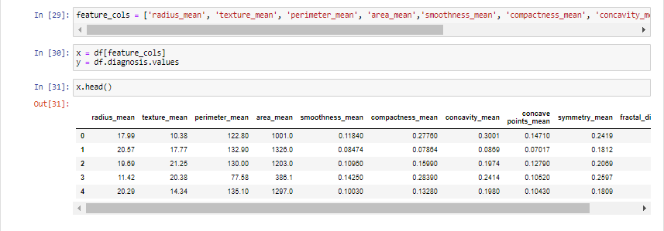

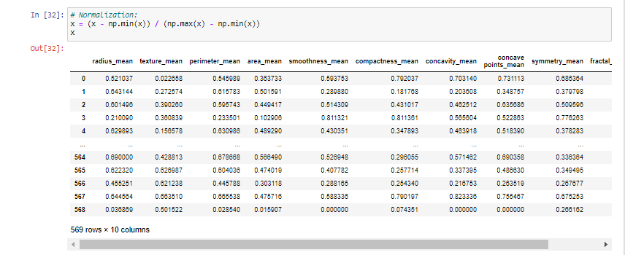

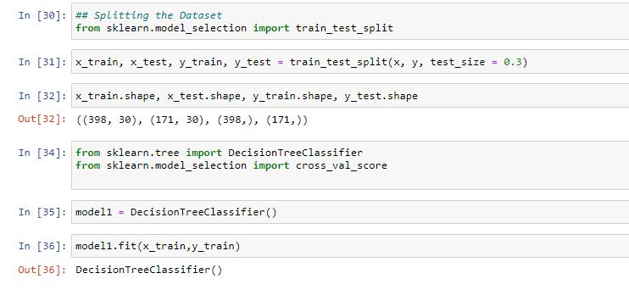

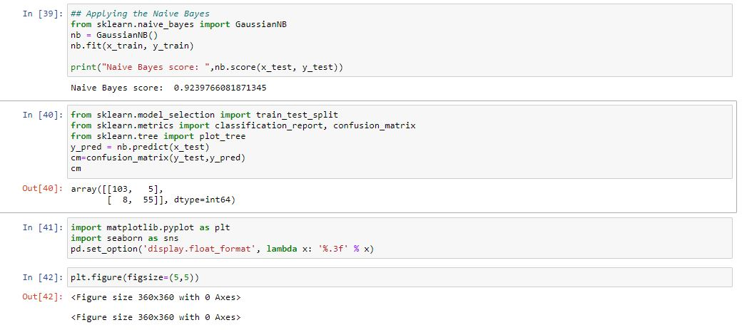

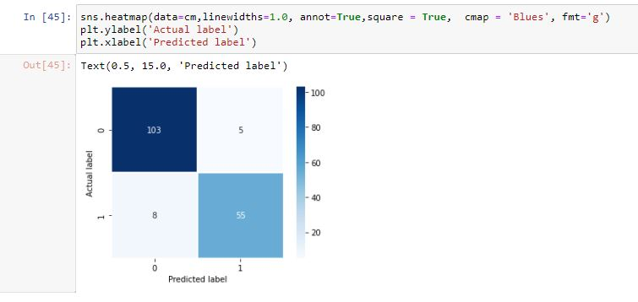

## FINAL RESULT:

